Supporting document for 7.1.1
MEASURES INITIATED BY THE INSTITUION FOR THE PROMOTION OF GENDER EQUITY:
Specific Facilities for Women
This document contains information regarding specific facilities provided for women in terms of:
1. Links to various facilities as displayed on the college website
2. Safety and security
3. Counseling
4. Common Room
5.CCTV camera

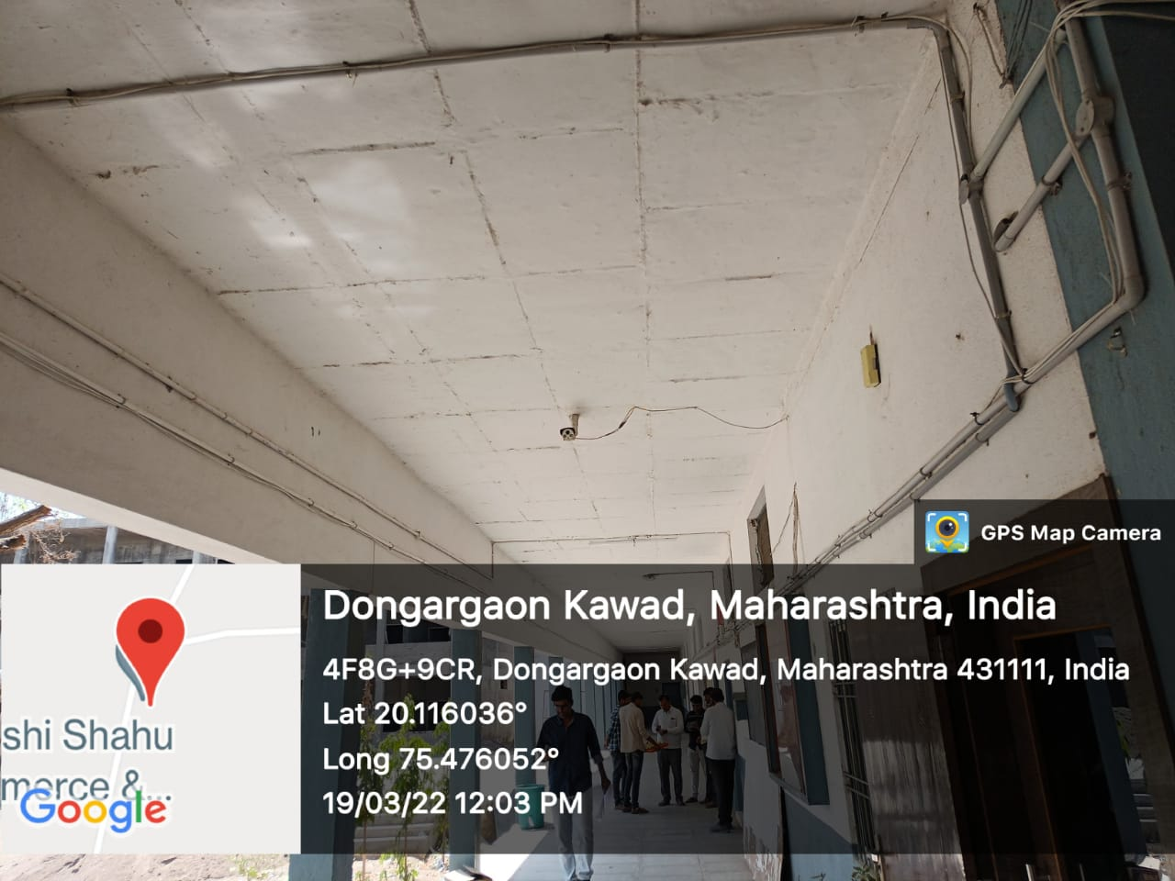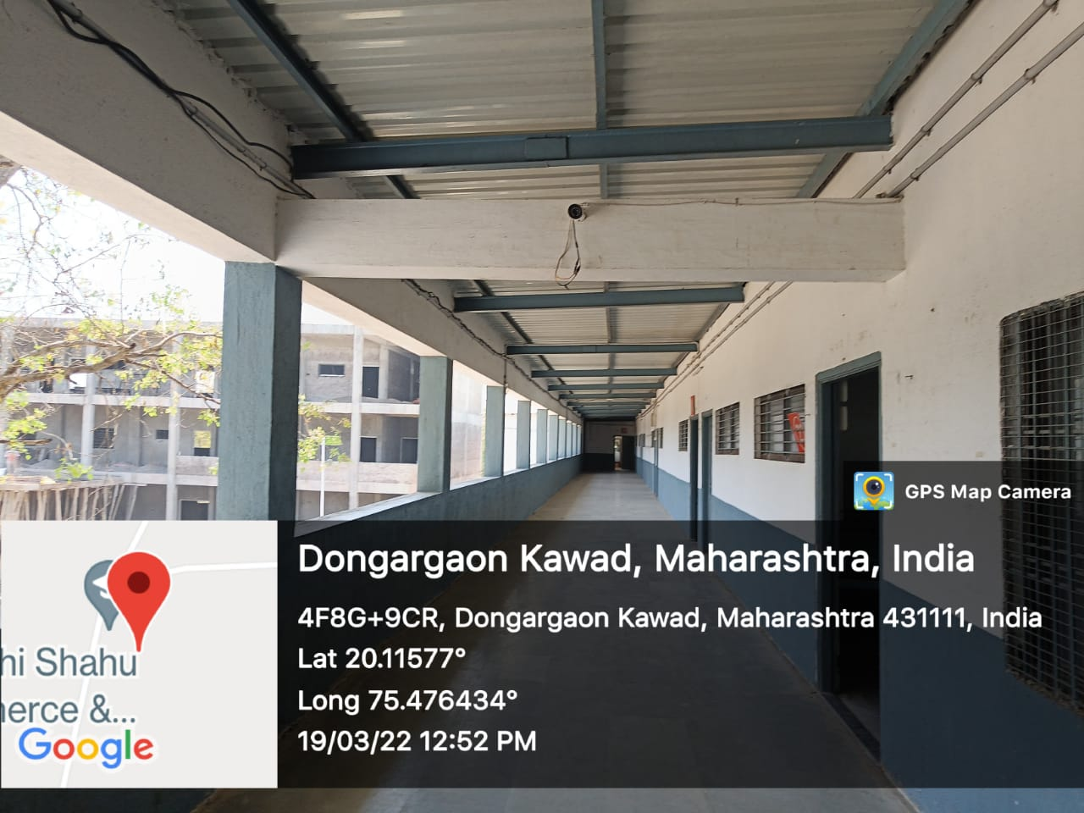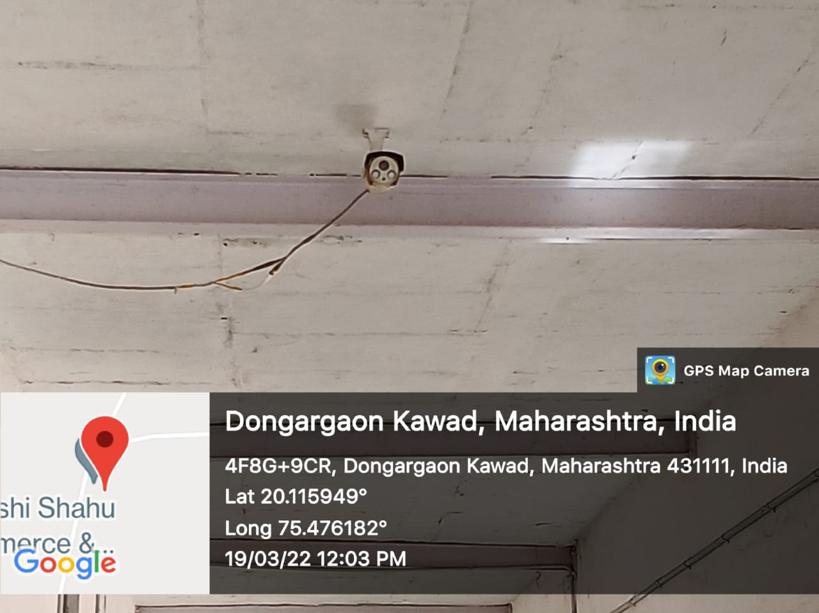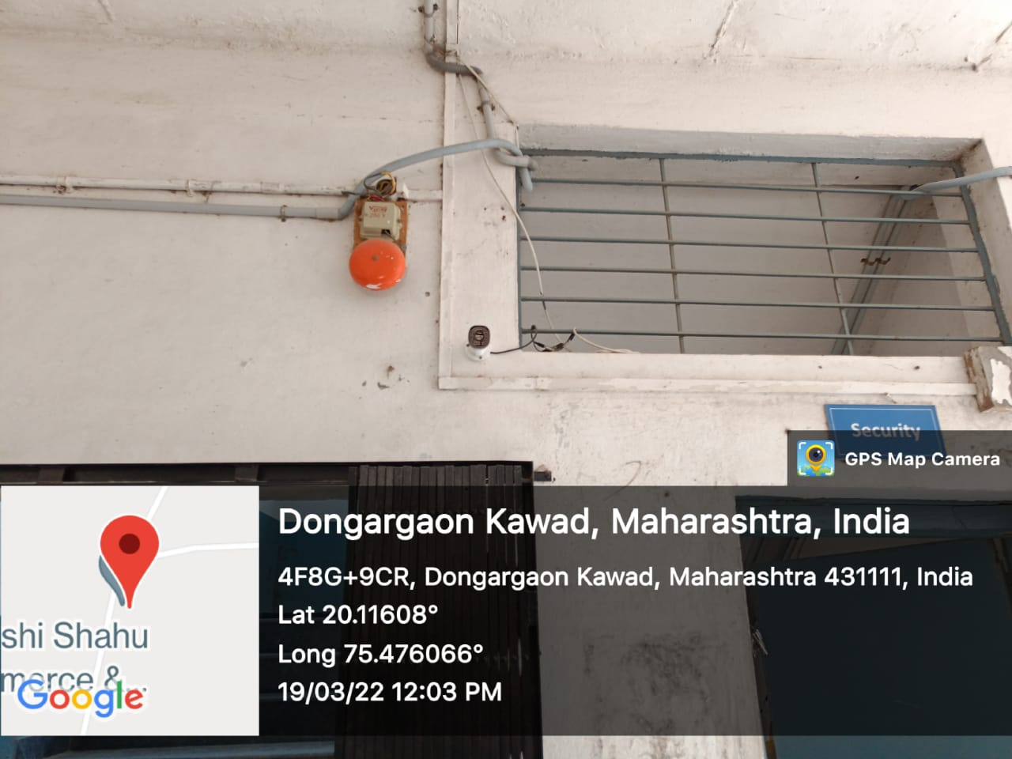

CCTV camera

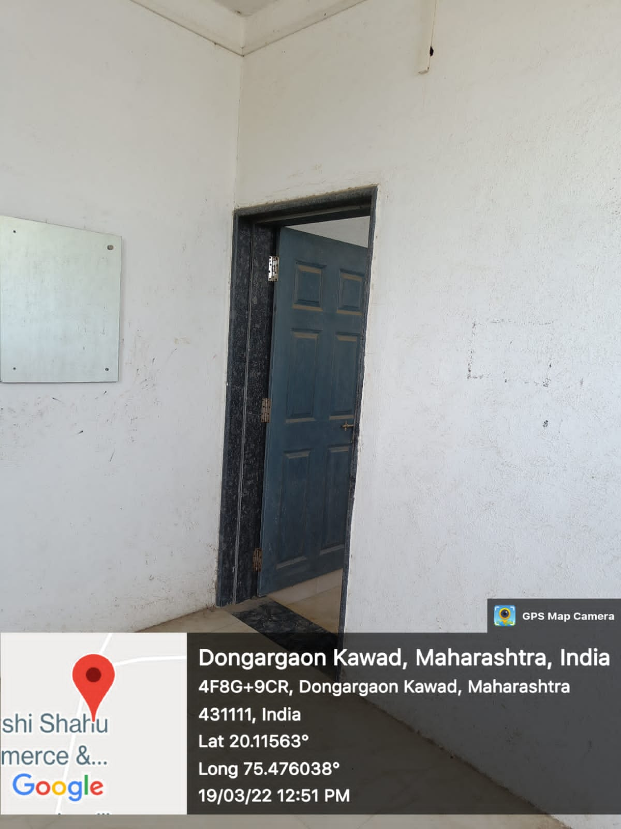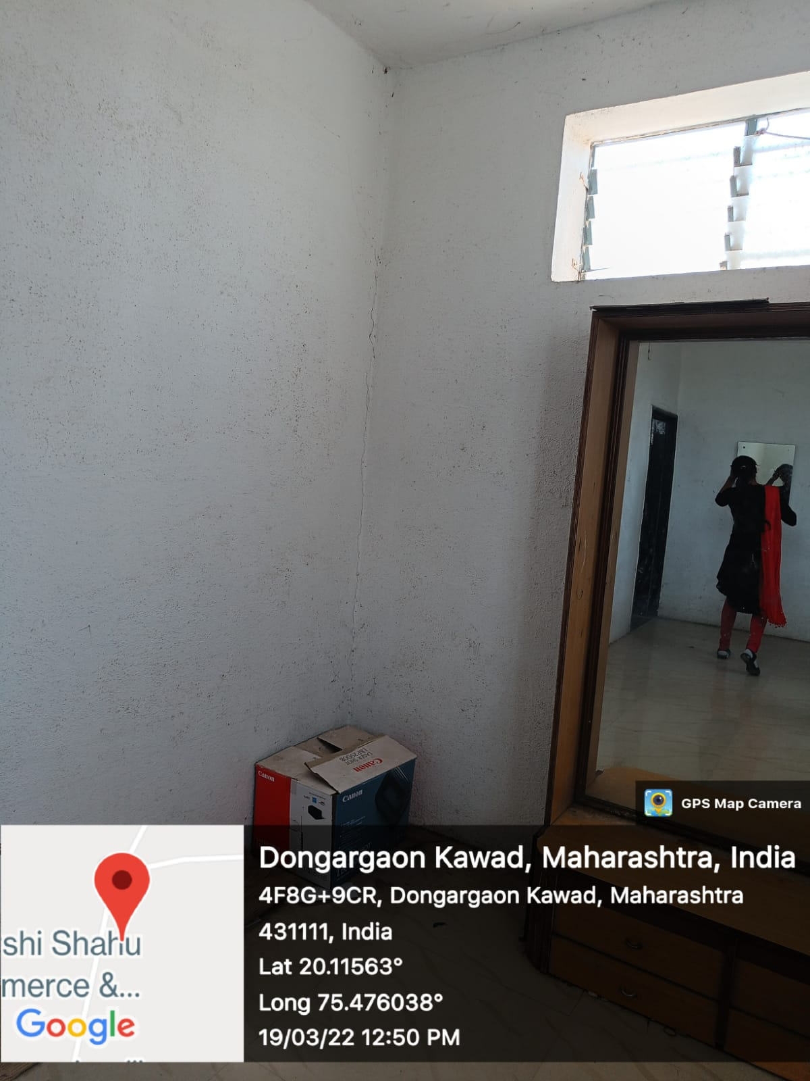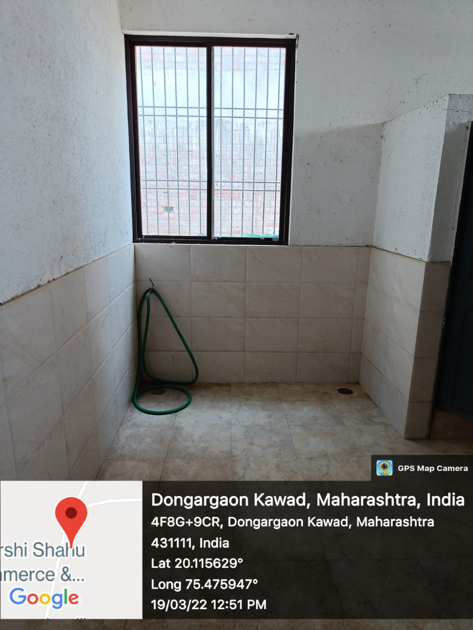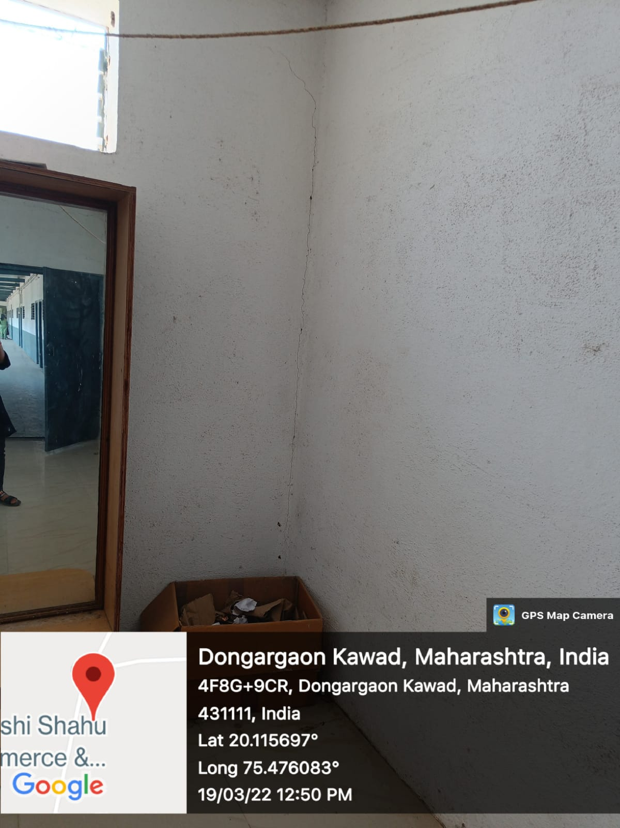
Ladies Common Room

Women’s Cell
NOTICE

All the girls students here by informed we will conducting online mode meeting of our women’s cell department on 20/08/2020 at 03:00 pm to 03:45pm.so please join it before 05 min.

Committee members Principal (Dr. T. B. Dale) ( Dr. S. b. jadhav)
(DR.A.S.THALE)

Discussion point in meeting
- Difficulties to learning online mode teaching.

- Make separate group for all girls students.

- To provide inspirational videos greater persons current affair of daily news paper on what’s up group.

- Students gives their name for remedial coaching classes.

- Some students have Exam related queries’.

Women’s Cell

NOTICE

All the girls students here by informed we will
conducting online mode meeting on 30/12/2020 at
03:30 pm to 04:00pm for the occasion of “Sawitribai phule jayanti”. On 03/01/20, we will Planning for Guest lecture ,students Participation in singing Competitions to sing poems in online mode. So Please all students compulsory to join it.
Committee members Principal
(Dr. T. B. Dale) ( Dr. S. b. jadhav)
(DR.A.S.THALE)

Discussion points in meeting
- The students gives their names for who are interesting to doing anchoring for our Progamme on 3jan 2022.
- The students give their name for participation in singing Competitions.
- The students give their name for vote of thanks of progamme.
- College library committee will provide online pdf book for students as per u r request
- Also college library committee will provide current affair in news paper in ur google classrooms.

Women’s Cell

NOTICE

All the girls students here by informed that we will conducting meeting on 01/03/2021 for “International Women’s Day” for celebrations on 08/03/2021,on that occasion we will plan to taking online mode “Essay writing competitions”. so please joining meeting online mode at02:30pm to 03:30 pm.

Committee members Principal
(Dr. T. B. Dale) ( Dr. S. b. jadhav)
(DR.A.S.THALE)

Discussion point in meeting
- Topic for essay writing competitions.

- Timing limit for competitions.

- How to send essay on group.

- Which topic to take for competitions.

- Please arrange debit competitions for students request.

